SET 12 – WEBSITE TRAFFIC ANALYSIS
Aim
To analyze website traffic using a line chart, bar chart, and table in R.
Algorithm
- Create the website traffic dataset.
- Plot daily page views using a line chart.
- Create a bar chart for click-through rates.
- Display the website traffic data in a table.
- Add appropriate labels and titles.
R Program
library(ggplot2)

traffic <- data.frame(
Date=as.Date(c("2023-01-01","2023-01-02","2023-01-03")),
Page_Views=c(1500,1600,1400),
CTR=c(2.3,2.7,2.0)
)

ggplot(traffic, aes(Date, Page_Views, group=1)) +
geom_line() +
geom_point() +
labs(title="Daily Page Views",
x="Date", y="Page Views")

ggplot(traffic, aes(Date, CTR)) +
geom_bar(stat="identity") +
labs(title="Click-Through Rate",
x="Date", y="CTR (%)")

print(traffic)
OUTPUT:
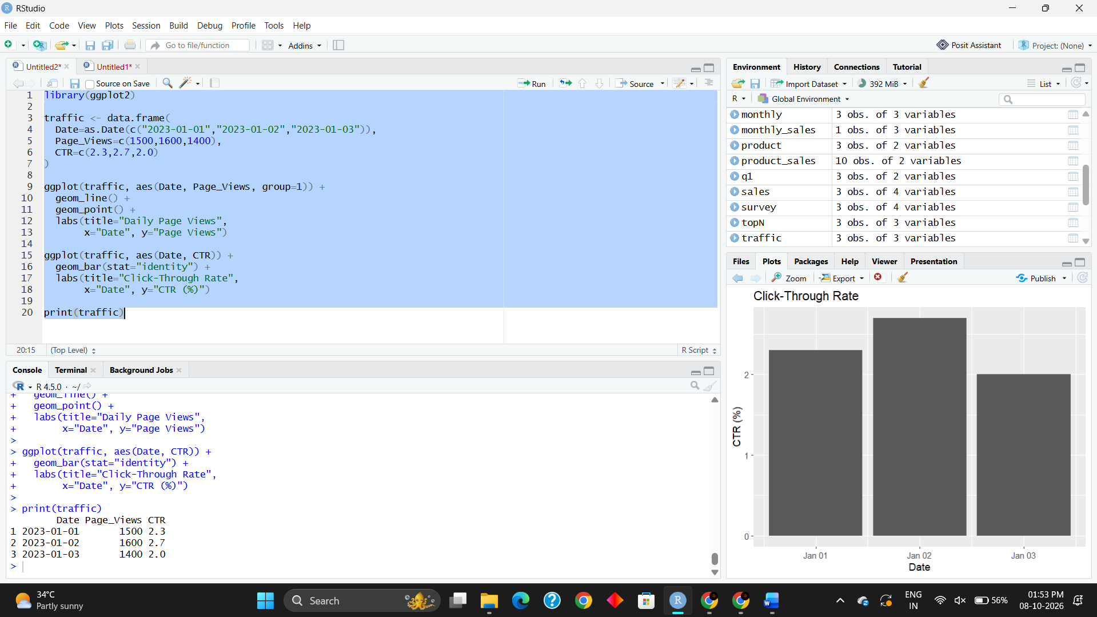

Result
The line chart successfully shows the trend in daily page views. The bar chart displays the click-through rate for each day, and the table presents the complete website traffic data.

